
Open Ended Lab (OEL) Report


STUDENT DETAILS
Name: Muhammad Ismail
Reg.no: SU-24-01-001-054
Semester/Program/Section: 3rd,BS CS-02
Department: CS & IT
Subject: Data Structures and Algorithms (DSA)
Date: 24-02-2026
Submitted to: SIR MR. NIAMAT ULLAH
PROJECT TITLE
Browser Back Navigation System Using Stack and Searching Algorithm
DESCRIPTION:

.In web browsers, when users visit multiple web pages, they can press the Back button to return to the previously visited page.
The pages must be returned in reverse order of visiting, which follows the Last-In-First-Out (LIFO) principle.
The objective of this Open-Ended Lab project is to design and implement a menu-driven Browser Navigation System that allows users to:
- Visit a new web page
- Go back to the previous page
- Search for a visited page
- Display browsing history
Selected Data Structures
Component | Data Structure / Algorithm | Reason
Page storage | Stack (Array-based) | Follows LIFO principle
Page search | Linear Search | Pages are unsorted
Display history | Stack traversal | Shows browsing order
Justification of Data Structure Selection
A stack is the most appropriate data structure for browser back navigation because it follows the Last-In-First-Out (LIFO) principle.
When a user visits a new page, it is pushed onto the stack.
When the user presses the back button, the most recently visited page is popped from the stack.
Using a queue would be incorrect because it follows FIFO order.
An array-based stack is selected due to simplicity and efficiency for small-scale browsing simulation.
Linear search is used because pages are not sorted.

Core Operations

a) Insert Operation (Visit Page)
User enters page URL
Page is pushed onto stack

b) Delete Operation (Back Button)
Top page is removed using pop
Error shown if stack is empty

c) Search Operation
Linear search performed in stack

d) Display Operation
Stack traversed from top to bottom
Algorithm / Pseudocode
Initialize empty stack
Repeat until Exit selected:
Display menu
Read user choice
If choice == Visit Page:
Input URL
Push into stack
Else if choice == Go Back:
If stack not empty
Pop page
Else
Show error
Else if choice == Search Page:
Input URL
Perform linear search
Else if choice == Display History:
Traverse stack
Else if choice == Exit
Terminate
Else
Show invalid choice
Time and Space Complexity Analysis
Operation | Time Complexity | Explanation
Push | O(1) | Constant-time insertion
Pop | O(1) | Constant-time removal
Search | O(n) | Linear traversal
Display | O(n) | Traverses all pages
Space Complexity: O(n) where n = number of visited pages.

Error Handling
The program handles:
Attempting to go back when stack is empty
Attempting to visit page when stack is full
Invalid menu choice

Menu-Driven Interface
- Visit New Page
- Go Back
- Search Page
- Display History
- Exit

C++ Implementation

PROGRAM SCREENSHOT:

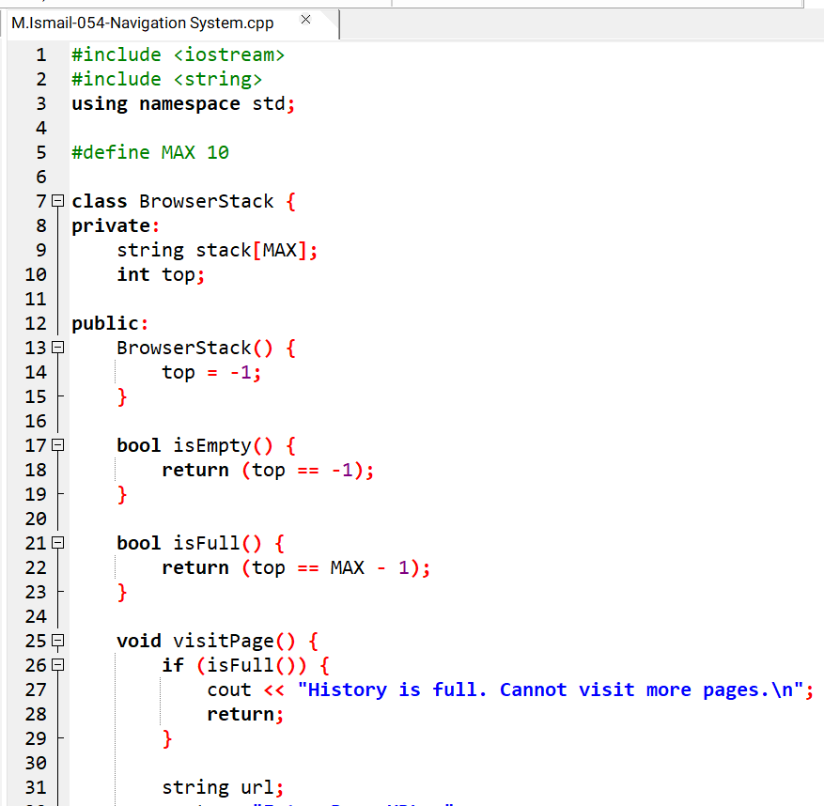
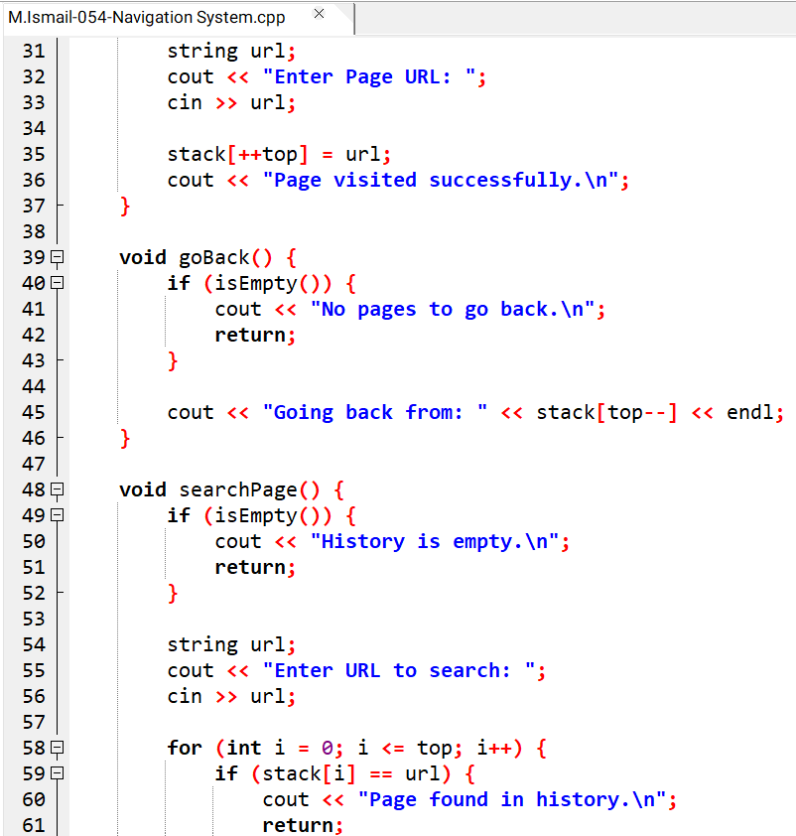

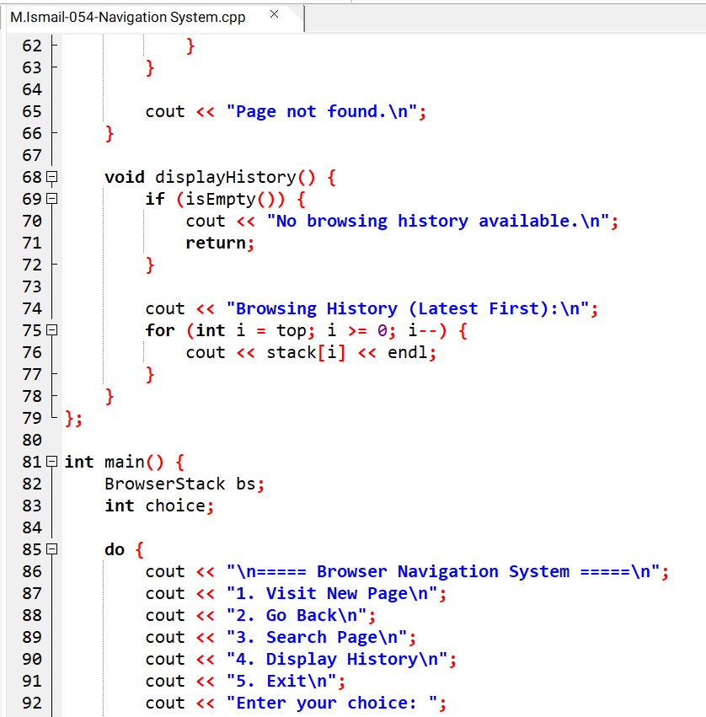

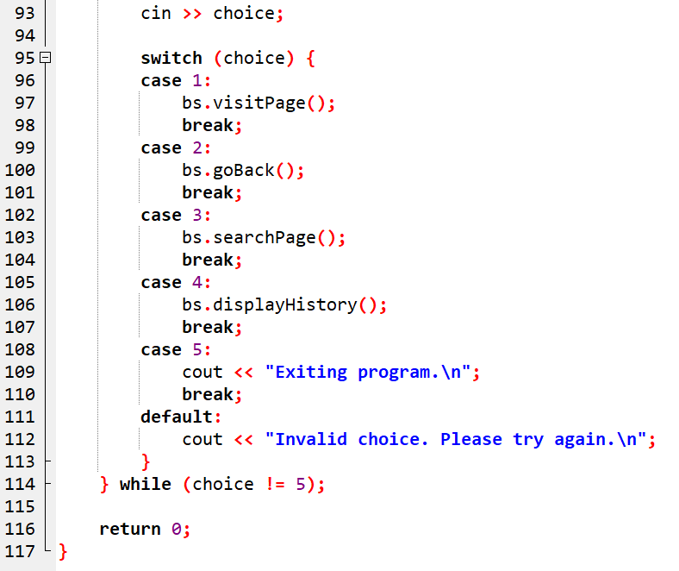

PROGRAM OUTPUT SCREENSHOT:
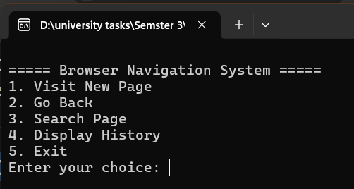
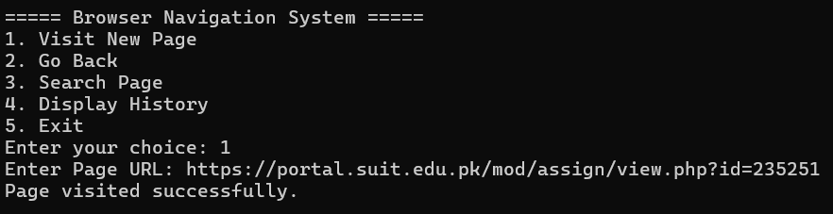
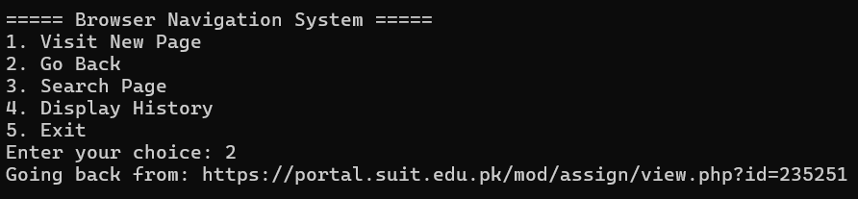
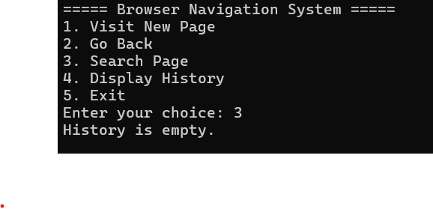

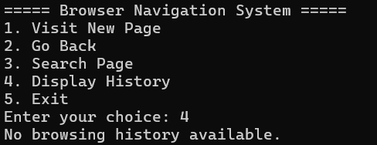

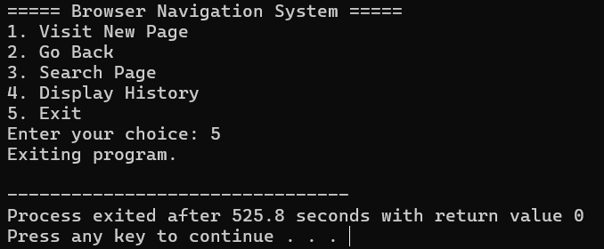

Instructor's Remarks

Grade:

